# Reference repo: <https://github.com/prafful/angular_may2020>

# Assignment 03

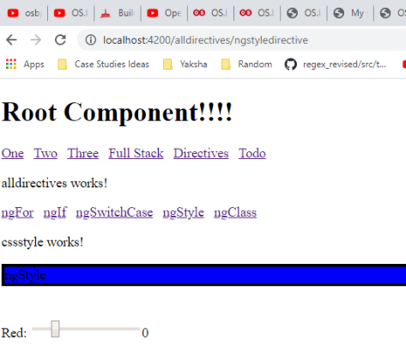

Implement the two more html5 input component of type “range” with label green and blue respectively for background color.

Red: <input type="range" >

Green: <input type="range" >

Blue: <input type="range" >

Implement html5 input component of type “range” with label red, green and blue respectively for font color.

Red: <input type="range" >

Green: <input type="range" >

Blue: <input type="range" >

**Expected output:**

Scrolling the range for respective colors, must change the background color and font color respectively. Hexadecimal color code must also be displayed.

**Background Color: #444444**

**Font Color: #888888**

# Assignment 04

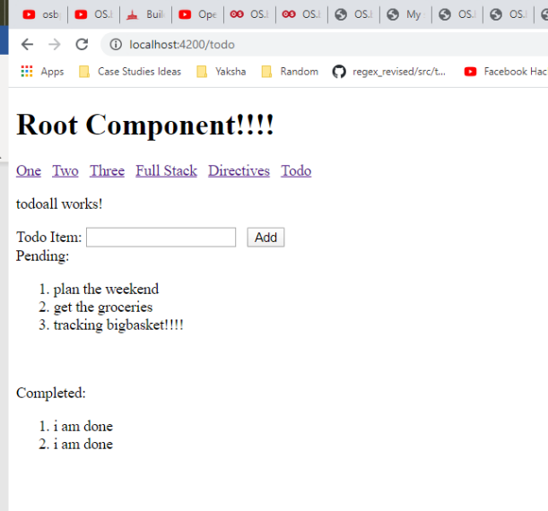

For the given todo component, do the following:

1. Implement button “Done” in front of each pending todo.
2. Clicking on “done” button must move the respective todo from pending to completed.
3. Implement button “Delete” in front of each completed todo.
4. Clicking on “Delete” button must delete the todo from respective array.
5. After clicking on “Add” button, text filed must become empty and focus of text input cursor must be present inside text field so that next todo item can be entered without using mouse.
6. On page load, input focus must be in text field.
7. On input of valid task in text field, hitting enter key must also add the new task to pending task list. Post that, text filed must become empty and input focus back to text field.